FACULTY EVALUATION
Programme Name: Social Entrepreneurship Program (SEP)- Growth MASTERCLASS Module 1 Kenya (2nd March 2026 - 6th March 2026)
Session: Reflection of SEP Learning
Faculty Name: Dr. Isaac Muiruri Gachanja
No. of Respondents: 7
No. of Participants: 10
Evaluation Parameter | (%) Individual Score | (%) Programme Average
Punctuality (Commencement and Completion of Sessions) | 90 | 93
How well do you understand the core concepts presented? | 97 | 95
Rate your confidence in applying the new skills learnt | 87 | 88
Degree of Faculty preparedness for the sessions | 93 | 95
Content and methodology of the program | 93 | 96
Quality of class and group discussions | 80 | 89
The information presented in the course is relevant to my work (ministry) | 97 | 97
Average scores | 91 | 93

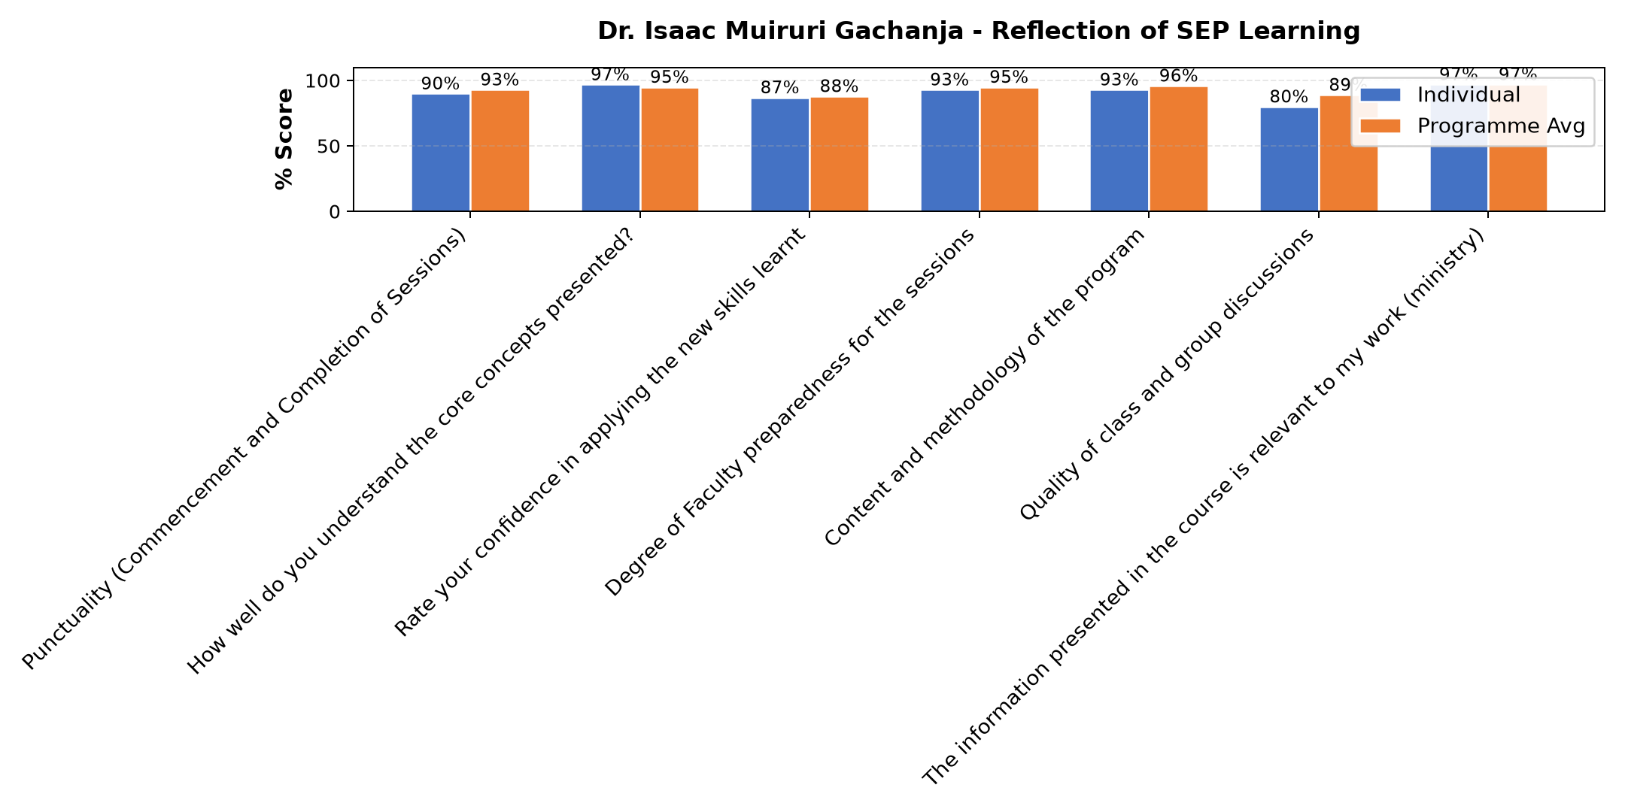

Comments & Feedback
- • Finances
- • Limited capital to expand services. Without financial resources, good plans may remain theoretical. But we thank God for the far we are.
- • So far I have tried to apply what I learnt. But at time we face different challenges in the enterprise which I look at them not really as barrier but stepping stones to achieve our goals and fullfil our mission with vision.
- • In the field of entrepreneurship what might hinder me from applying skills I have applied is Incase I will be transfered before I finalize the strategic plans,goals and objectives put across to actualize the plans ahead but if I continue the way things are currently,with new skills I am learning I will probably implement and see to it that the charism of the sisters of Mary of kakamega is aligned with the objectives and results obtained to make sure that the girl child is secure and progressing well in education sector living in comfortable atmosphere.
- • An extra mile to be initiated to help mitigate the challenges.
- • The skills gained from session has equipped us with practical knowledge on how to run a social enterprise not only as a charitable service but as a sustainable and impact-driven social enterprise. God bless Strathmore, ACWECA and all the faculties for the effort of making us realize that sustainability can be achieved even from compassionate services
- • I thank Strathmore university with the help of Hilton foundation for sensitization and close follow ups in our social enterprises to make sure that the businesses which we began are ongoing and progressing well.
SUBMITTED THROUGH:
SBS Evaluation Automation System

